**Question 1**

**How is the daily returns of NASDAQ distributed? Does it follow a normal distribution?**

The daily return graph of NASDAQ is not a normal distribution curve though close to a normal distribution. The graph also shows that the mean of the data is greater than the median, therefore implying that the distribution is skewed to the right.

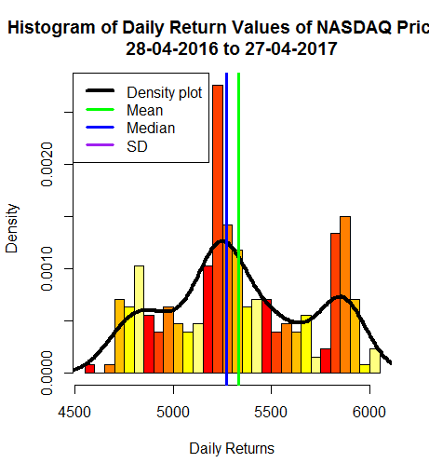

**Question 2**

**Are any obvious trends visible in movement of NASDAQ prices for the period under study?**

The graph shows two noticeable trends in the data. The graph has two humps, one to the left of the median and the other to the right that seem to closely resemble mirror images of each other. There is also a small tail in the far left and right of the distribution.

**Question 3**

**Analyze the measures of central tendency calculated and offer opinion on the overall risks and possible rewards associated with investing in the NASDAQ index for the period under study.**

Investing in NASDAQ can be profitable in the long run compared to the short run. NASDAQ data shows great fluctuations that display a pattern that when utilized well can be beneficial both to investors and speculators. Judging from the trend displayed in the graph, NASDAQ prices are likely to fall for a few months the continually rise.